**Condition-Based Maintenance of Naval Propulsion Systems**

**ANUSHA KARUNAKARAN**

**BALPREET SAWHNEY**

**RAJA TULSIYANI**

**SHREY MODI**

­­ **TABLE OF CONTENTS**

|  |  |  |
| --- | --- | --- |
|  |  |  |
| **1.** | **EXECUTIVE SUMMARY** | 3 |
| **2.** | **PROBLEM STATEMENT** | 3 |
| **3.** | **SEMMA METHODOLOGY** | 4 |
|  | 1. **Sample the Data** | 4 |
|  | 1. **Explore the Data**   **-Explore Outliers**  **-Explore Missing values** | 4  4  5 |
|  | 1. **Modify the Data**   **-Data Transformation**  **-Data Partitioning** | 5  6  6 |
|  | 1. **Develop the Model**   **-Logistic Regression**  **-Random Forest** | 6  7  9 |
|  | 1. **Assess the Results** | 10 |
| **4.** | **RESULTS** | 10 |
| **5.** | **CONCLUSIONS AND RECOMMENDATIONS** | 11 |
|  | **REFERENCES** | 12 |
|  | **APPENDIX** | 12 |

# **EXECUTIVE SUMMARY**

Today, a significant amount of the world’s global GDP is being spent on maintenance activities, especially for addressing equipment breakdown or failure. Operational efficiency, equipment ROI and safety considerations give rise to an industry need to ensure that the equipment is functional and utilized to its potential. The maintenance of the several components of a Ship Propulsion Systems is an onerous activity, which needs to be efficiently programmed by a shipbuilding company in order to save time and money. The replacement policies of these components can be planned in a Condition-Based fashion, by predicting their decay state and thus proceed to substitution only when really needed. Analyzing the data from sensors can create game-changing ways in the following:



# **PROBLEM STATEMENT**

The main aim of the project is to predict degradation trends by studying the effects on the engine measurable parameters such as the temperature and pressure at critical points of a gas turbine engine and to propose a suitable maintenance policy using predictive modeling.

# **SEMMA METHODOLOGY**

**SEMMA** is an acronym that stands for Sample, Explore, Modify, Model, and Assess. It is a list of sequential steps developed by SAS Institute, one of the largest producers of statistics and business intelligence software. It guides the implementation of data mining applications. The steps are as follows:

**Step 1: Sample the Data**

We are considering the complete dataset.

**Step 2: Explore the Data**

**Dataset:** The experiments have been carried out by means of a numerical simulator of a naval vessel (Frigate) characterized by a Gas Turbine (GT) propulsion plant. The different blocks forming the complete simulator (Propeller, Hull, GT, Gear Box, and Controller) have been developed and fine-tuned over the year on several similar real propulsion plants. In view of these observations, the available data are in agreement with a possible real vessel.

1. **Explore Outliers:**

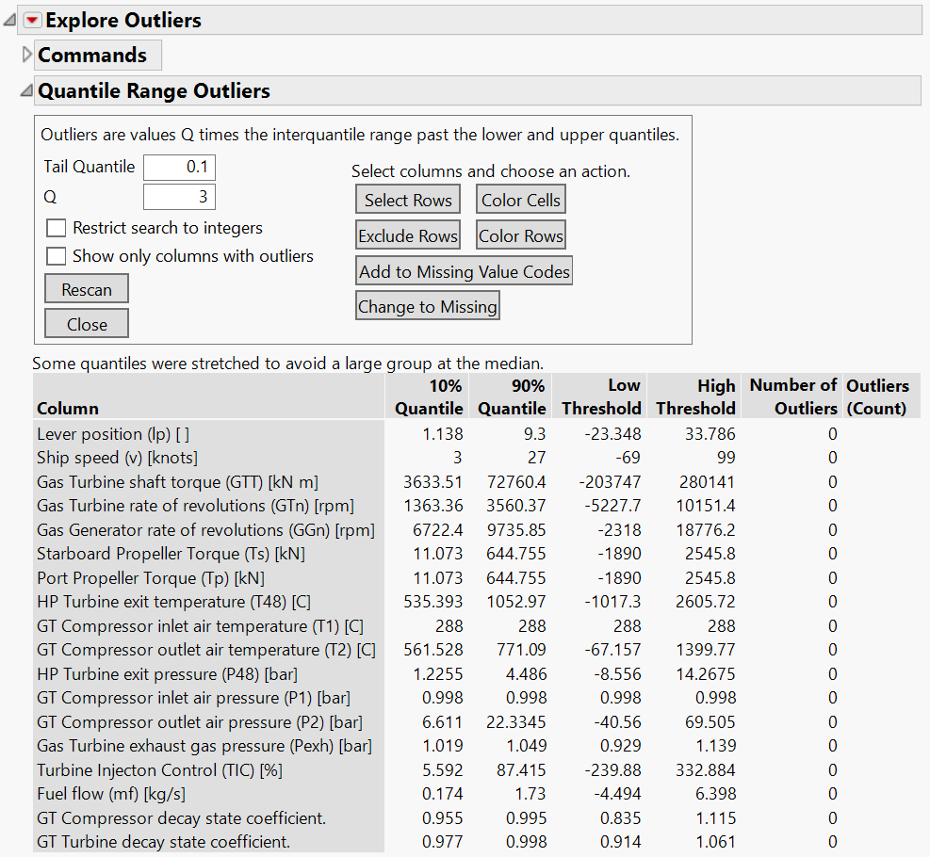

1. **Explore Missing values:**

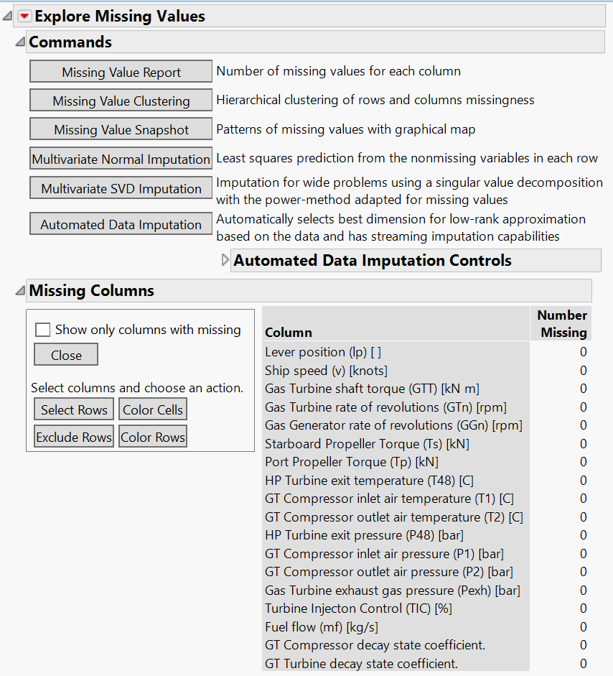

**Step 3: Modify the Data**

1. **Data Transformation:** We transformed the fields to model our data in such a way that we can easily determine the values of the GT Compressor decay state coefficient and GT Turbine decay state coefficient.

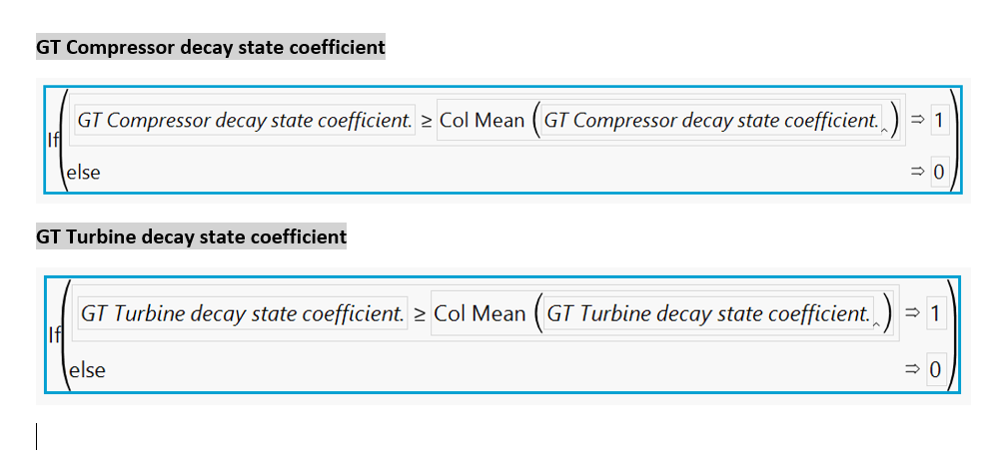

1. **Data Partitioning:** Use Make Validation Column to divide the data into training, validation and test data.

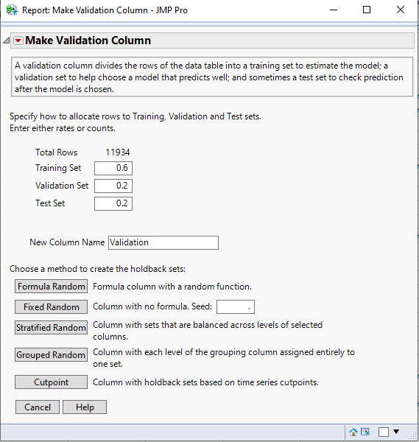

**Step 4: Develop a Model**

For this model, the following are the Supervised techniques used to predict the maintenance through Compressor Decay coefficient and Turbine Decay coefficient:

* Logistic Regression
* Random Forest (Bootstrap)

1. **Logistic Regression**

Logistic regression produces estimates of the model intercept and coefficients, together with quality statistics for the individual parameters and the model as a whole. When applied to new data, the logistic regression produces a probability ranging from zero to one reflecting the relative likelihood that the case belongs to the target class, given the known values of predictor variables.

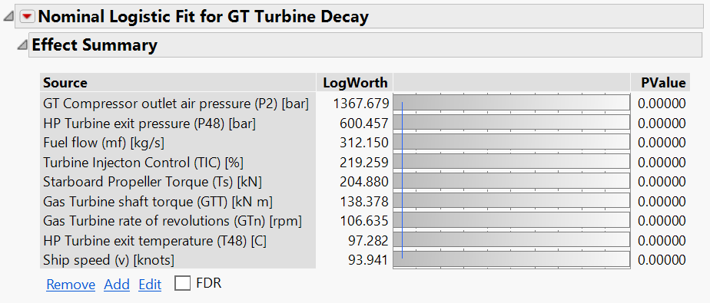

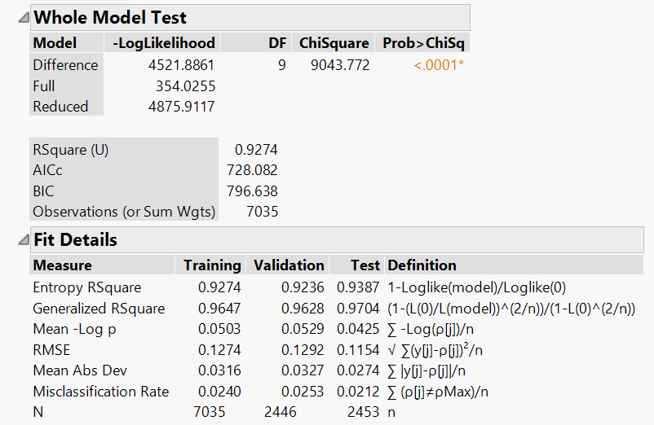

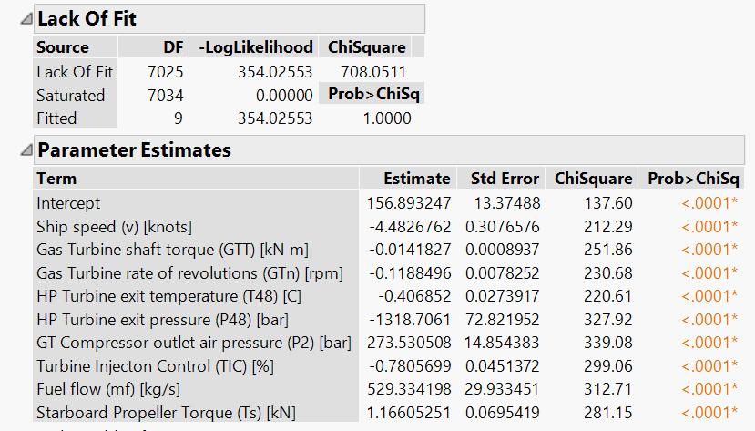

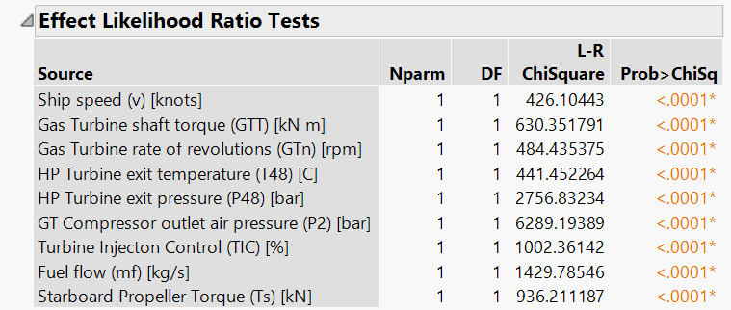

1. **Random Forest**

The random forest model is an ensemble model that can be used in predictive analytics; it takes an ensemble (selection) of decision trees to create its model. The idea is to take a random sample of weak learners (a random subset of the training data) and have them vote to select the strongest and best model. The random forest model can be used for either classification or regression. In the following example, the random forest model is used to classify the Iris species.

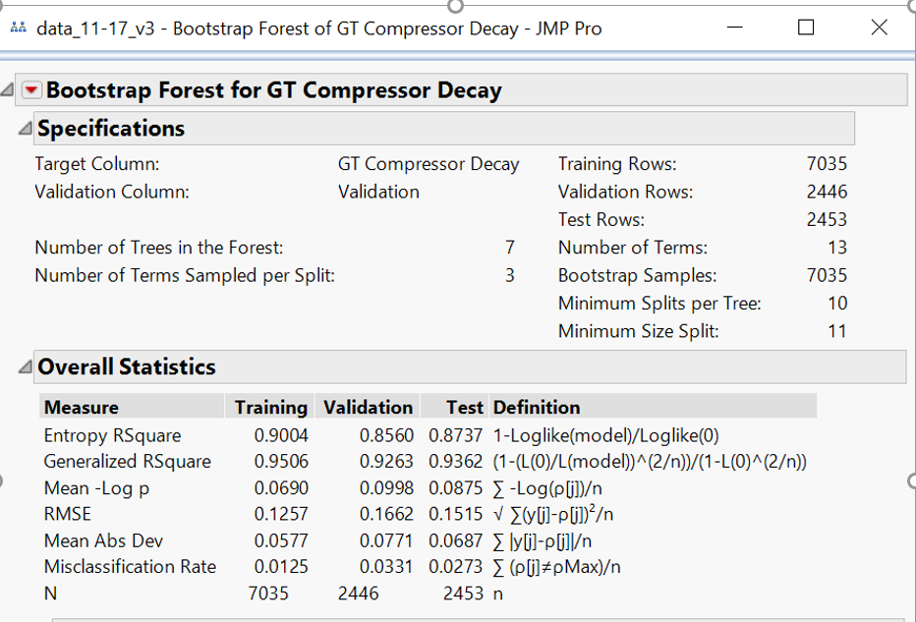

**The other techniques that we used are:**

* Neural Networks
* Decision Trees

**Step 5: Assess the Results**

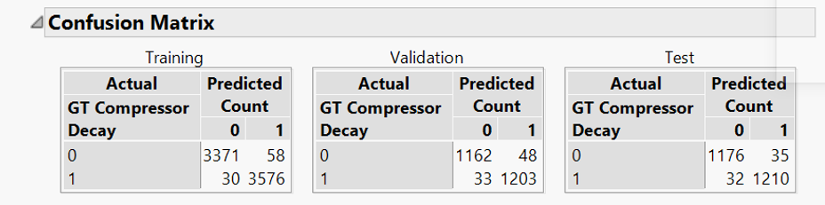

From the confusion matrix, we determine the following metrics,

**Accuracy of the Training Model - 92.35%**

**Accuracy of the Validation Model - 96.68%**

**Accuracy of the Testing Model – 97.14 %**

# RESULTS

The CBM approach to maintenance is very generic, depicting a horizontal view to a crosscut problem in different heterogeneous domains. When a more vertical view is taken into consideration, focusing on the maritime domain, **repair maintenance expenses for conventional ships can amount up to about 20% of total operability costs**, including manning expenses, insurance, and administration costs.

For naval applications, maintenance optimization is a key task, focused to reduce operations costs while getting the optimal availability of the ship for the intended service; such optimization is the result of **a trade-off between excessive maintenance and machinery downtime**, where CBM helps opening the door toward **best balancing costs and availability**. In other words, CBM enables a just-in-time deployment of ship maintenance, by allowing to plan and execute maintenance activities only when needed.

# CONCLUSIONS AND RECOMMENDATIONS

Gas turbine (GT) gas-path fault diagnostics is a key element of an overall engine condition-based monitoring (CBM) system providing enhanced safety, reliability, and availability along with optimal operation and maintenance costs. Hence predictive maintenance is achievable, affordable, and delivers measurable business benefits. The easiest way to get started is with an industrial platform centered on a rule-based model, which enables teams to quickly define, simulate and deploy a predictive maintenance solution for their products. Advanced analytics with predictive alerts and automated root cause analysis can be applied at a later phase — once sufficient historical data has been collected to accurately identify issues before they occur. Manufacturers are also turning to predictive maintenance for Factory, or a connected factory, by installing sensors in machines, workstations. Security cameras or worker equipment, to predict issues across the factory floor.

# REFERENCES

[1] <http://aircconline.com/csit/papers/vol9/csit90601.pdf>

[2]<https://scholar.google.com/scholar_lookup?title=Random%20forests%20model%20selection&author=I.%20Orlandi&publication_year=2016>.

[3] <https://www.spectec.net/maintenance-materials-management>

[4] [www.elsevier.com/locate/oceaneng](http://www.elsevier.com/locate/oceaneng)

[5] [Shin JH, Jun HB. On condition-based maintenance policy. J Comput Des Eng. 2015;2(2):119–27.](Shin%20JH,%20Jun%20HB.%20On%20condition%20based%20maintenance%20policy.%20J%20Comput%20Des)

# APPENDIX